What is the correlation (R2 value) between sales and income?

It’s 0.78

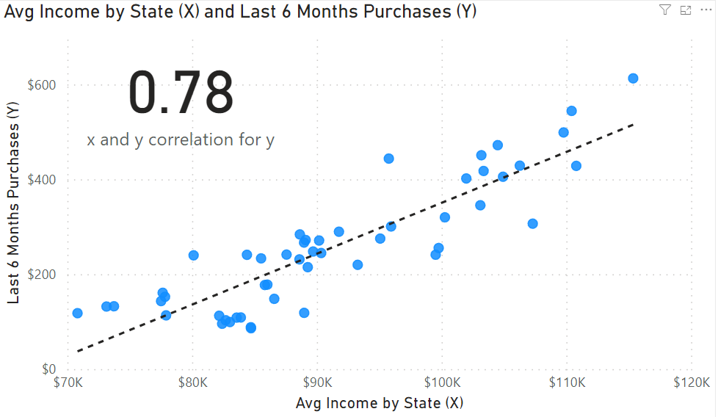

What is the correlation (R2 value) between customer ratings and product return rate?

It’s 0.69

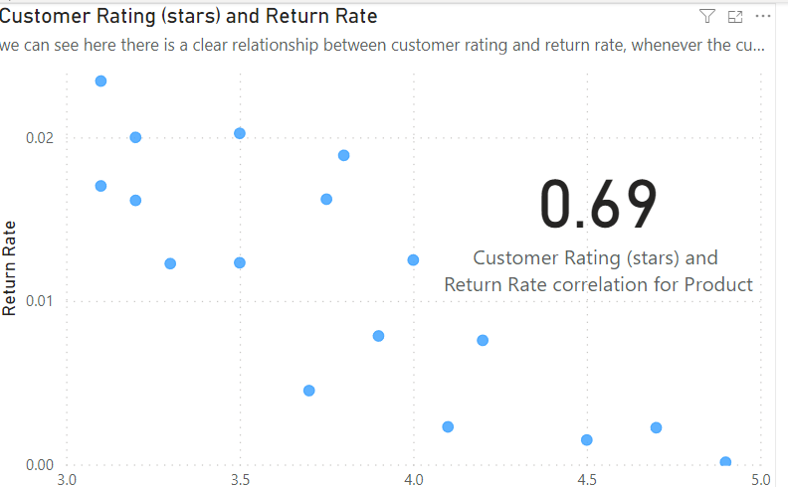

What are the linear regression formulas to predict customer income from customer sales?

B is -722 and M is 0.01

Which customer do you predict has the highest income?

AAgu38852 with a predicted income of 558,143.93

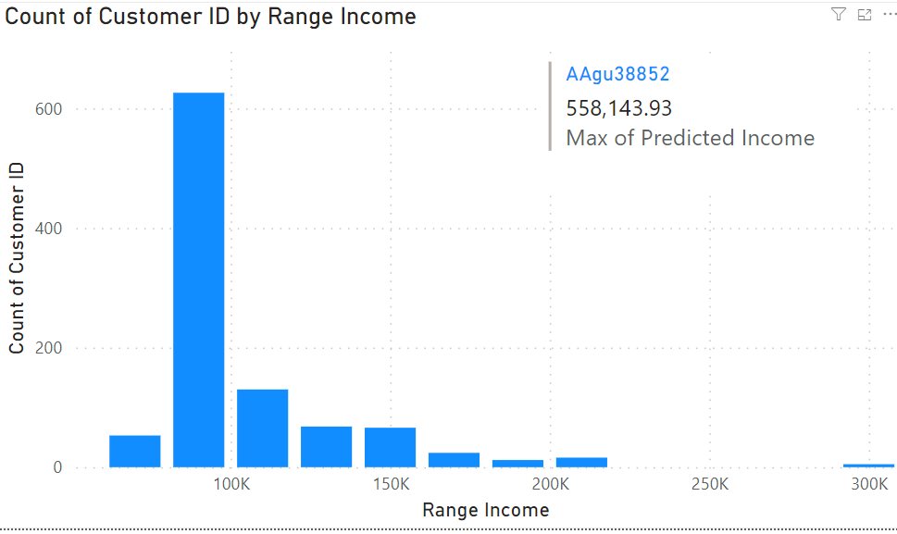

Which product will be advertised the most?

FlipFlops

As we can see from the report there is a clear relationship between customer predicted income and sales, so targeting customers with higher income usually will lead to increased sales in total.

Another piece of advice I would like to give to the marketing team is to contact customers and try to find out why they have rated some products with a low rating, because a lower rating will lead to a higher return rate.

I have also made a product recommendation system and I combined it with a map so you will be able to know which product you should market for each individual customer, and in which state you should market the product in case you were targeting new customers.